**Practical No:05**

**Roll No: 01 Date:27/07/2022**

**Aim: Configure Auto Profiles ACU Utilities**

**Design :**

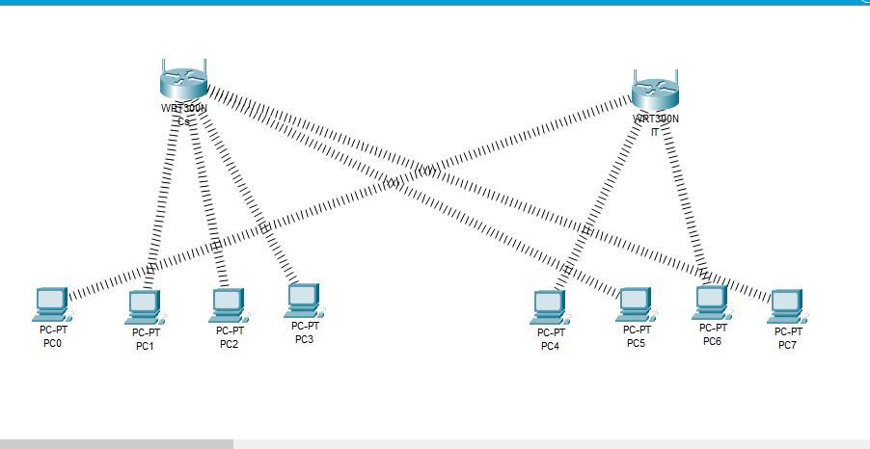

**WirelessRouter0:**

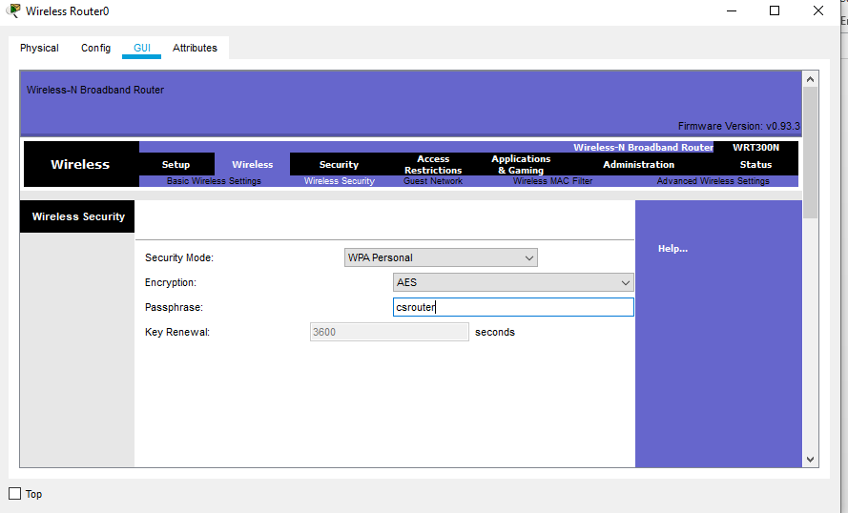

**WirelessRouter1:**

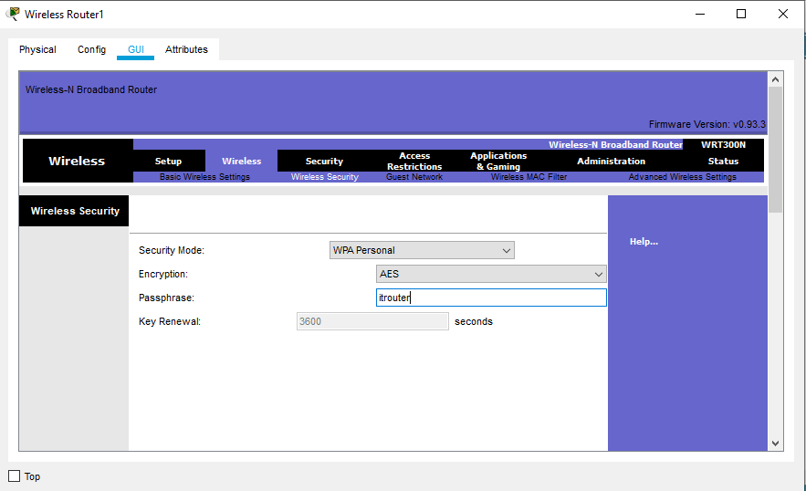

**PC0:**



**To connect csrouter:**

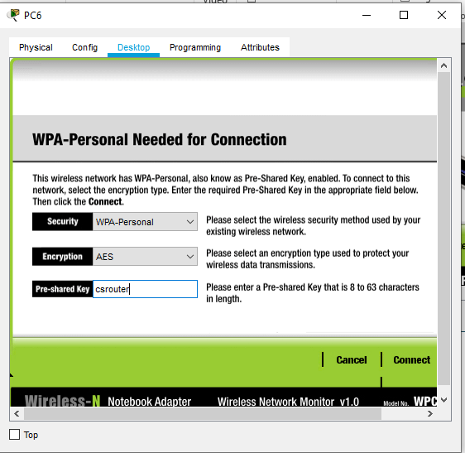

**To connect itrouter:**

